# **INTRODUCTION**

## Overview

**Gadget Galaxy** is a mobile application providing an all-in-one shopping experience for electronic gadgets. The application allows third-party sellers to list their products and customers to browse, purchase, and review them. This project provides an in-depth overview of the application’s business requirements, functionality, data flows, database schemas, and UI designs. The project consists of two phases. The first phase is on the development of MySQL relational database that provides us the structure of different entities like user, seller, product, etc., and various concepts related to data normalization, retrieval.

## Application Business Requirements and Functionality

**GadgetGalaxy** aims to develop the electronic gadget shopping experience by attracting a large and loyal user base while expanding our network of various sellers. Our primary goals include enhancing user purchase and maintenance through all-in-one and personalized experiences, building best seller network, and ensuring a comprehensive and up-to-date product catalog7]. Ultimately, our goal is to deliver exceptional customer experiences by providing a secure, user-friendly platform that offers the latest electronic gadgets at competitive prices.

### Functional Requirements

#### 1. User Authentication and Registration

* **User Registration**: Users can register by providing necessary details such as username, email, and password.
* **User Login**: Registered users can log in using their email and password.
* **Security**: User information is securely stored in the MySQL database with hashed passwords.

#### 2. Product Management

* **Seller Registration**: Third-party companies can register as sellers.
* **Product Listing**: Sellers can list their products with attributes like name, description, price, quantity, and category, and modify or delete them.

#### 3. Product Listings

* **Browse and Search**: Users can browse products based on categories, keywords, and filters.

#### 4. Shopping Cart and Order management

* **Shopping Cart**: Users can add products to their cart, view the contents, and proceed to checkout
* **Checkout Process**: Secure checkout process with an order summary and payment integration.

#### 6. User Profiles

* **Profile Pages**: User profiles display order history, contact details, and basic information.
* **Order History**: Users can view their order history and details.
* **Seller Profiles**: Sellers can manage their product listings, basic info, and their reviews.

### Non-Functional Requirements

#### 1. Database Design

* **Normalized Database Schema**: Designed a relational database schema to store user, product, order, and related information.

#### 2. Security and Privacy

* **Secure Authentication**: Implemented secure authentication mechanisms to protect sensitive data by storing hashed passwords etc.

#### 3. Performance and Optimization

* **Optimized Queries**: Ensured efficient retrieval of information by optimizing database queries.

#### 4. User Interface (UI) Design

* **User-Friendly UI**: Designed user-friendly interface mock screens for the application.

# **ENTITY RELATIONSHIP DIAGRAM**

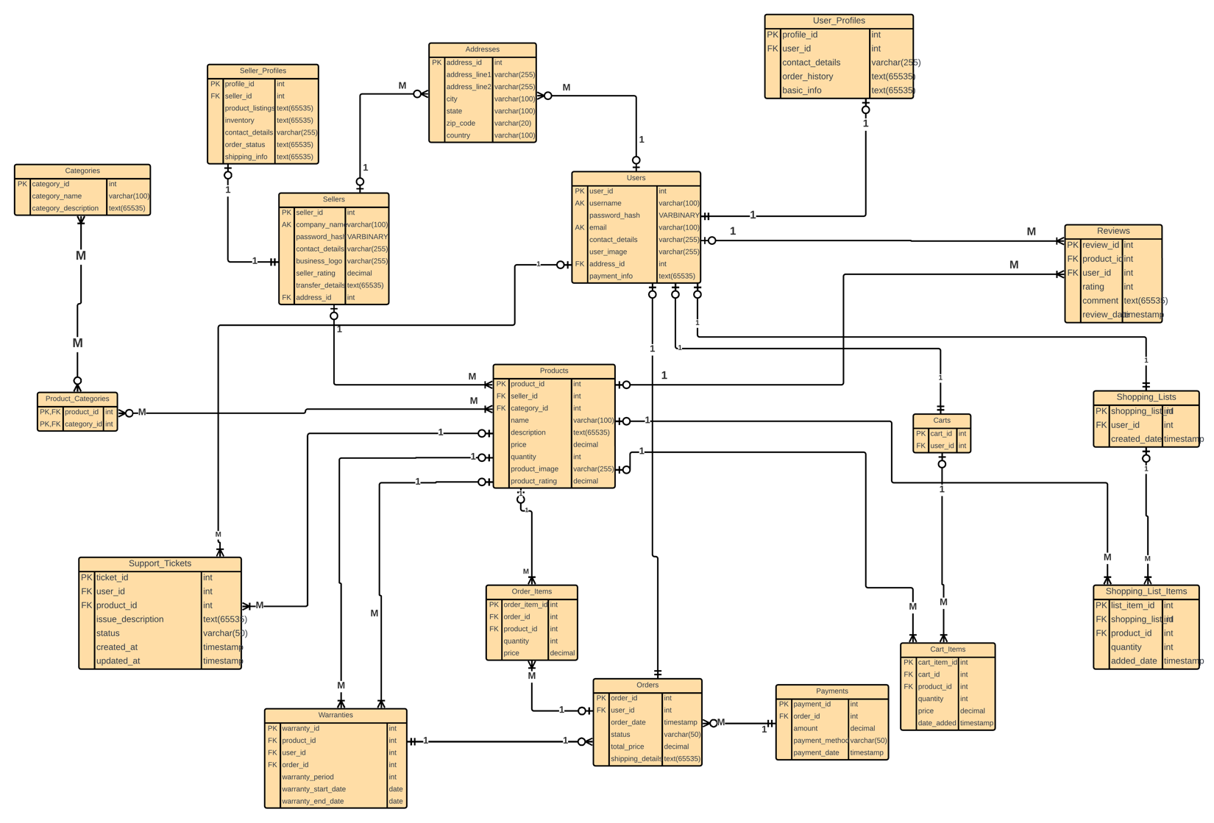

In the below ER diagram[6] for **GadgetGalaxy**, we used Crow's Foot notation[2] to represent the cardinality and relationships between various entities in our database[1]. This notation is particularly useful in illustrating the nature of relationships and the number of instances of one entity that can be associated with instances of another entity. In our ER diagram, we focus on key entities such as Users, Sellers, Products, Orders, and Reviews. Each User can place multiple Orders, but each Order is placed by a single User, showing a one-to-many relationship. Similarly, Sellers can list multiple Products, while each Product is listed by a single Seller, also a one-to-many relationship.

Products and Reviews exhibit a one-to-many relationship[1] where a single Product can have multiple Reviews, but each Review is associated with one Product. Orders and Order_Items have a one-to-many relationship, highlighting that each Order can include multiple Order_Items, each referencing a single Product. The diagram also includes relationships for supporting entities such as Payments, Warranties, and Support_Tickets, each appropriately linked to their primary entities to ensure data integrity and consistency throughout the database. This clear representation helps in understanding the data flow and dependencies within the system.

# **DATA FLOW DIAGRAM**

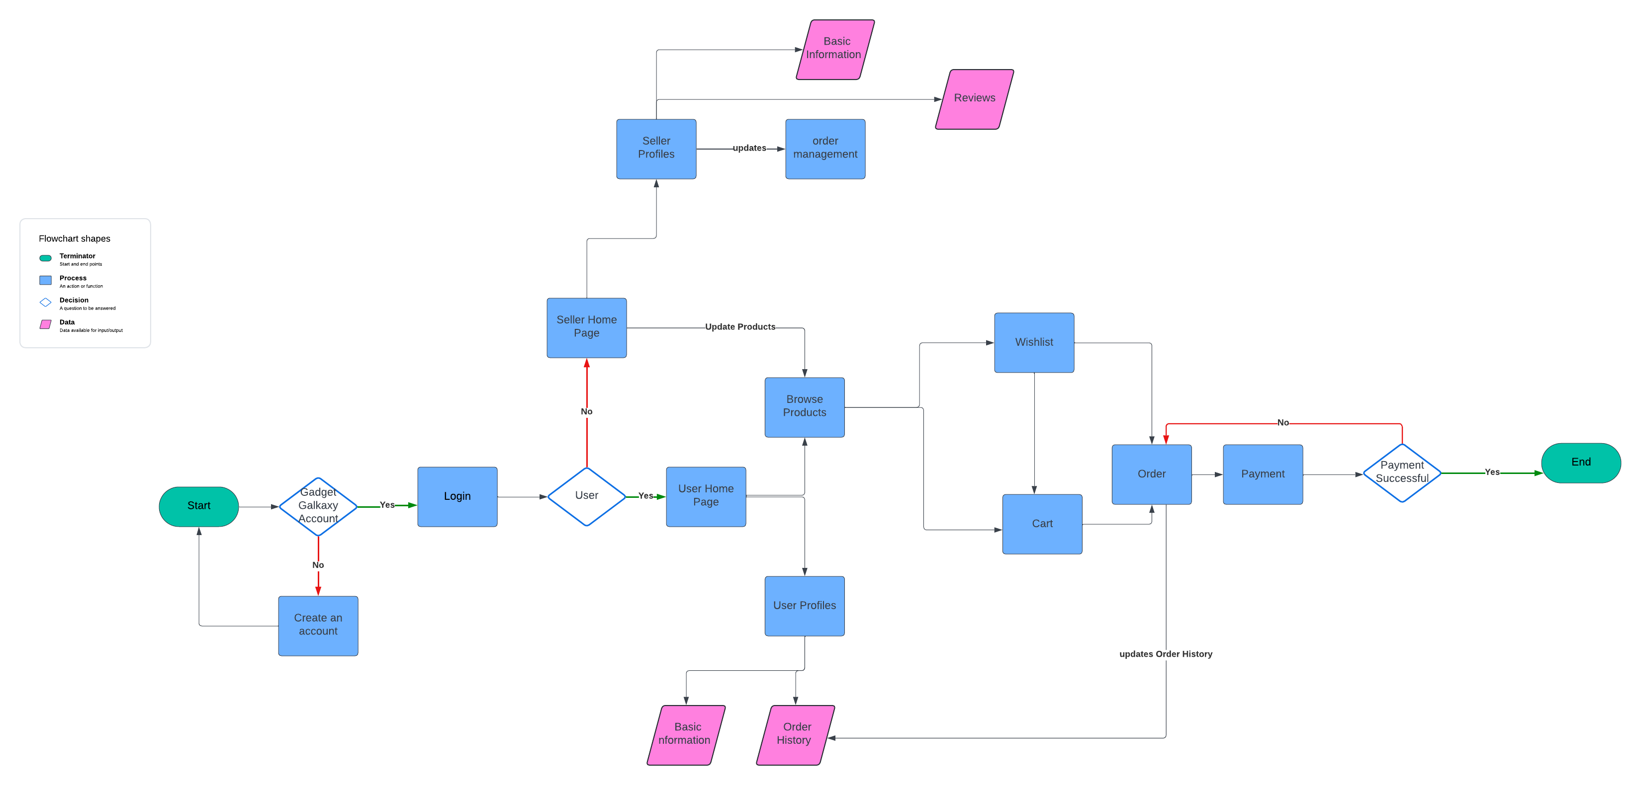

# **DESIGN TECHNIQUES**

## Normalization

Normalization is a database design technique that aims to reduce redundancy and dependency by organizing fields and table of a database[3]. The main objectives of normalization are to ensure data consistency and integrity while minimizing duplication. In the GadgetGalaxy platform, normalization has been effectively implemented across various tables to enhance the efficiency and reliability of data storage and retrieval.

The Addresses table stores address details separately, avoiding redundancy across multiple tables.

Both Users and Sellers tables reference the Addresses table through a foreign key (address_id), ensuring that address details are not duplicated in these tables. These tables also achieve normalized forms as all non-key attributes are fully functionally dependent on the primary key, and there are no transitive dependencies[3].

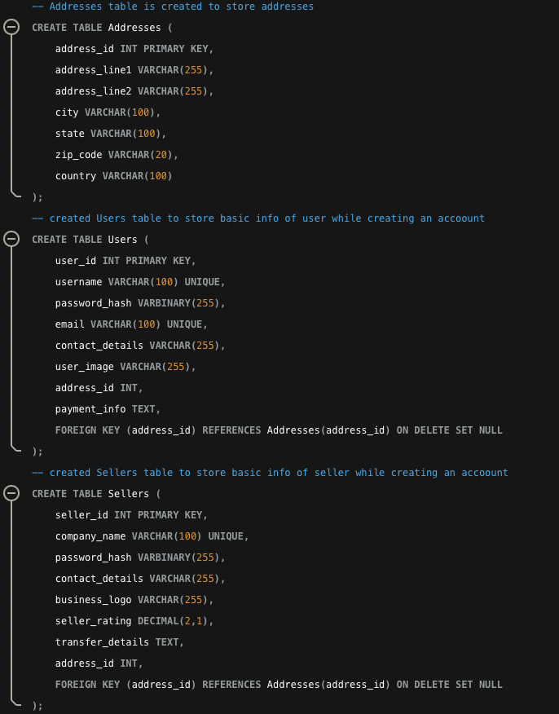



Similarly, the Products table references the Sellers and Categories tables, ensuring that product details are linked to their respective sellers and categories without redundancy. The Product_Categories table creates a many-to-many relationship between products and categories, which is a normalized approach to handle such relationships. These tables are normalized as they have primary keys and all non-key attributes depend only on these keys.

## INDEXING:

Indexing is a critical database optimization technique used to improve the speed and efficiency of data retrieval operations[4]. An index is a data structure that allows the database to find and access data faster. By creating indexes on specific columns that are frequently used in queries, especially in WHERE clauses, joins, and sorting operations, we can significantly enhance the performance of our database.

In the **GadgetGalaxy** database schema, we have strategically created several indexes to optimize various data retrieval operations. Here are the indexes we created.

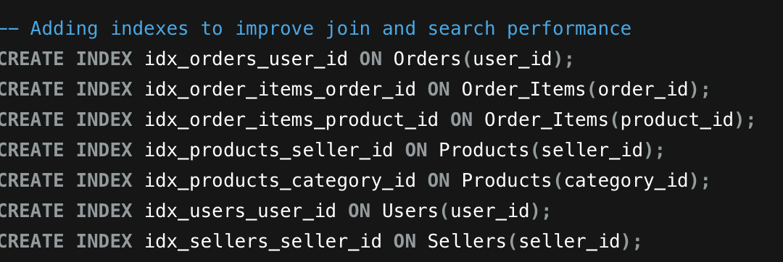

The indexes created ensure that queries involving user orders, product management, and seller profiles are executed quickly, providing a smooth and responsive experience for users and sellers alike.

# **USER AUTHENTICATION AND REGISTRATION**

**User Authentication and Registration** are critical components of the **GadgetGalaxy** application, ensuring secure access and personalized experiences for users. These features are designed to safeguard user information while providing a seamless onboarding process for new users and a straightforward login mechanism for returning users.

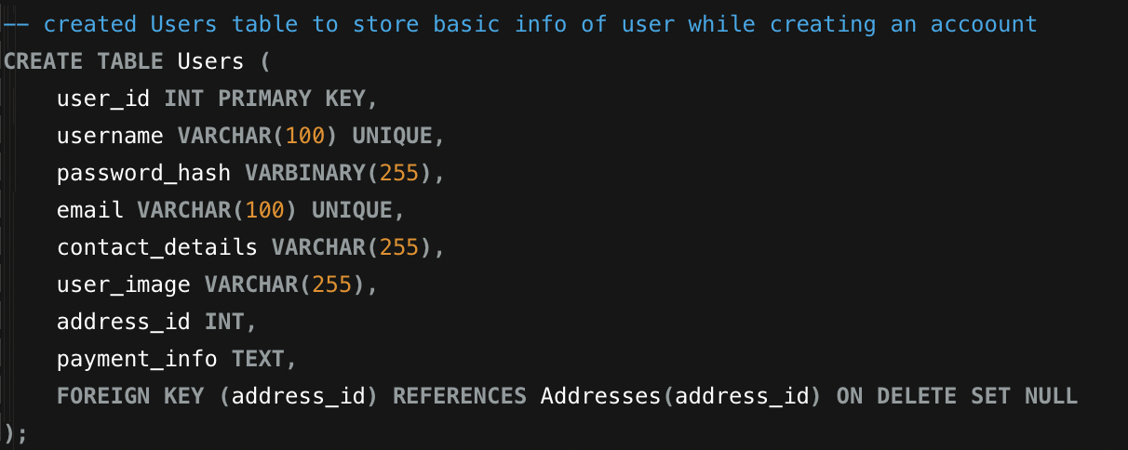

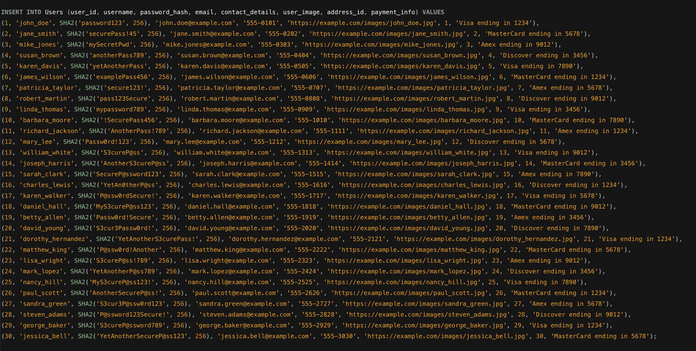

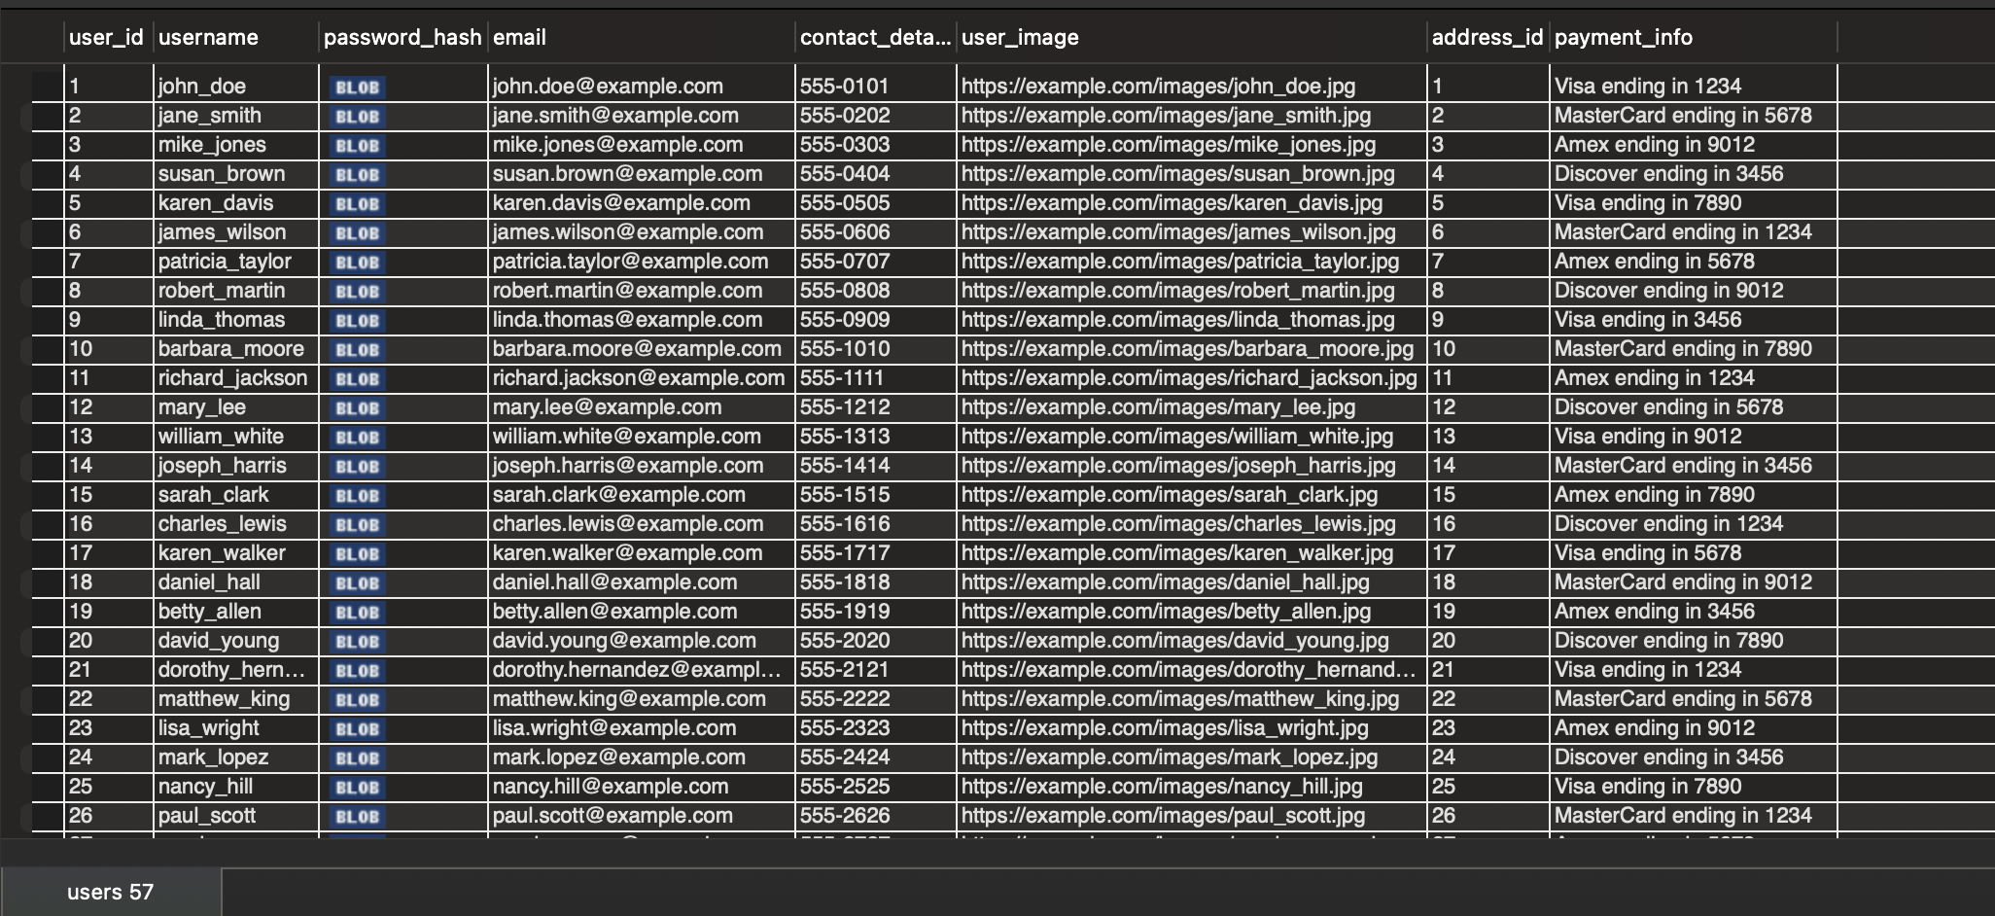

## USER INTERFACE DESIGN

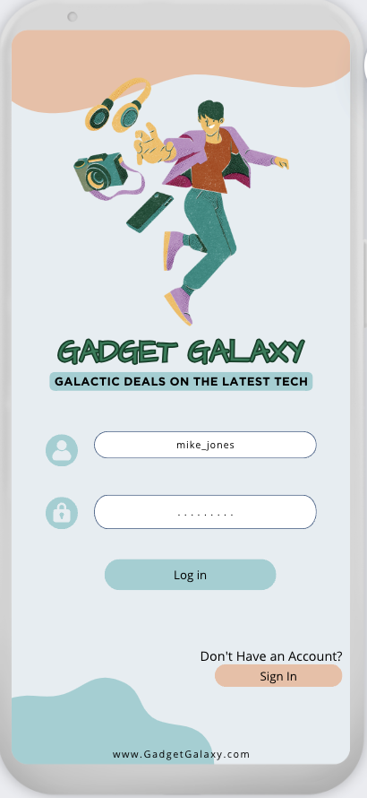 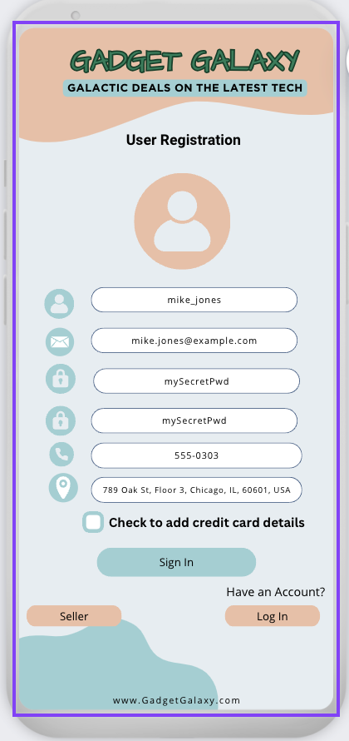 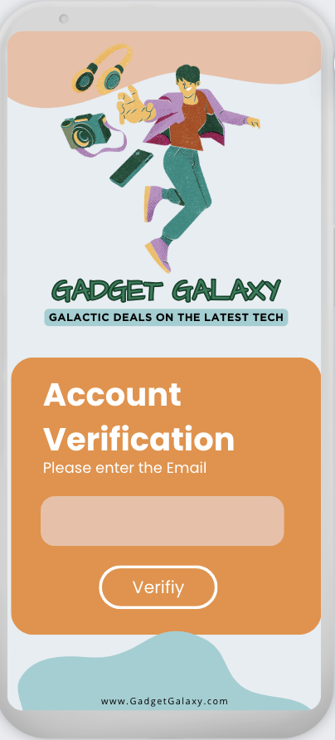

### User Registration and Authentication

When a new user wishes to join GadgetGalaxy, they go through a simple registration process. The user provides essential details such as username, email, password, and contact information. For security, the password is hashed using a robust hashing algorithm (such as SHA-256) before being stored in the database. The user's information, including the hashed password, is securely stored in the Users table in the MySQL database. For existing users, GadgetGalaxy provides a secure authentication mechanism, Users enter their registered username and password on the login screen. The entered password is hashed and compared with the stored hashed password in the database. In order for more security we verify the email if user is unable to login.

Login User – screen 1

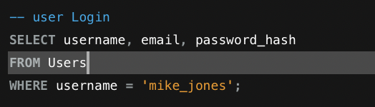 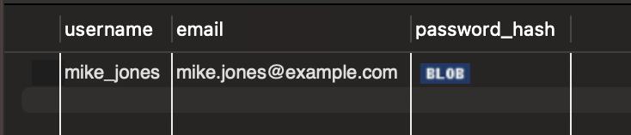

In the backend, we verify with a hashed password and move to the home page.

Create user – Screen 2





Verify User- Screen 3

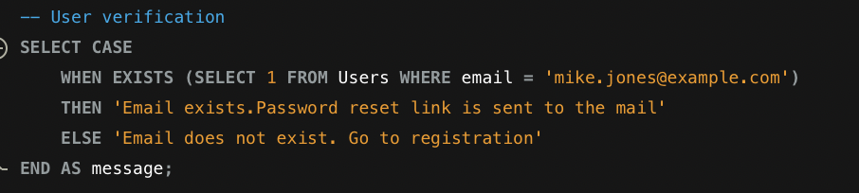 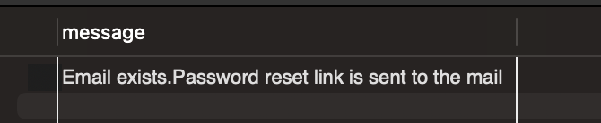

# **PRODUCT MANAGEMENT**

**Product Management** is a core functionality of the **GadgetGalaxy** platform, enabling sellers to effectively manage their inventory and ensuring an all-in-one shopping experience for users. Sellers register or log in and have the ability to view add, edit, and delete product listings directly from their dedicated seller page. For this, we have created Sellers, Products, and Categories tables.

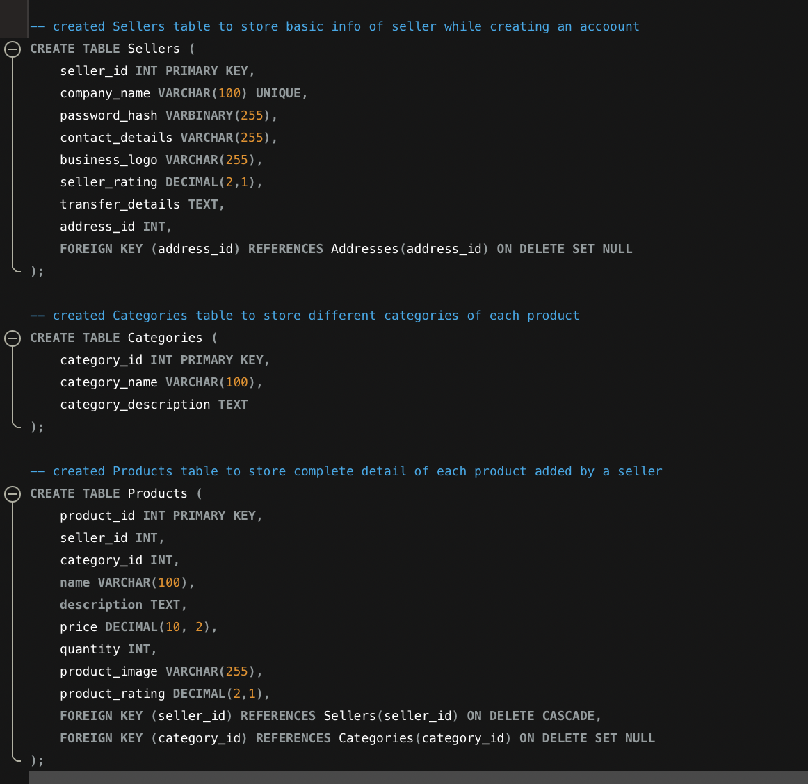

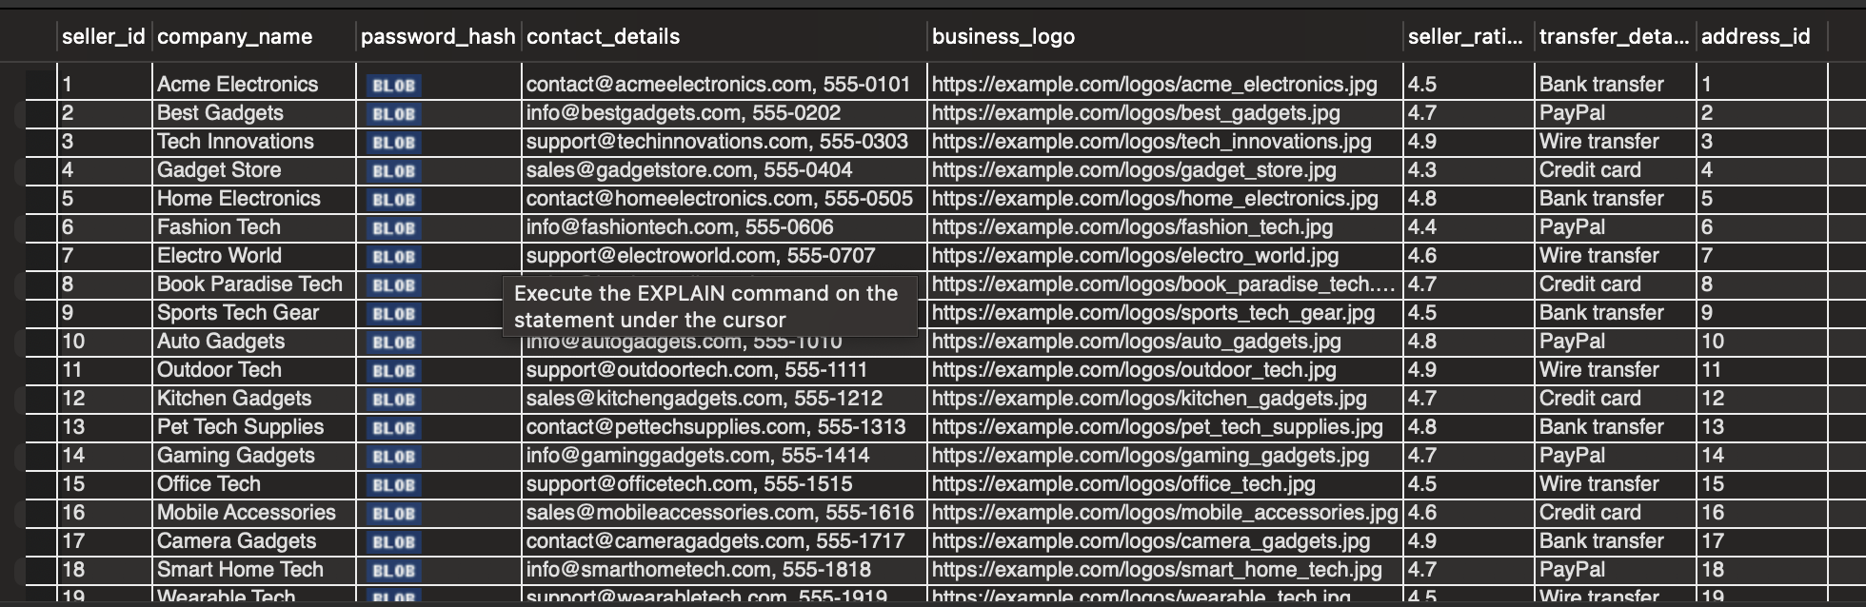

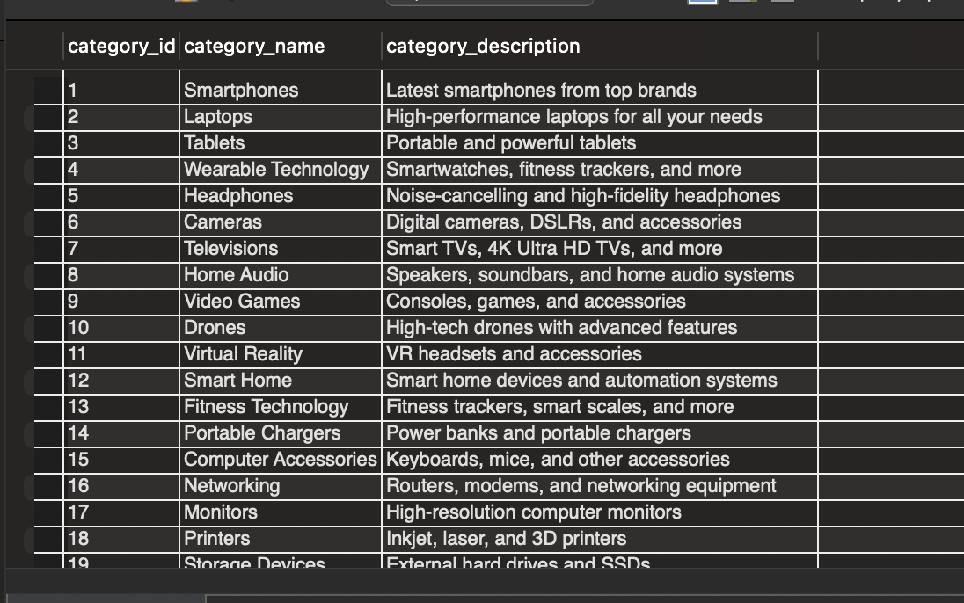

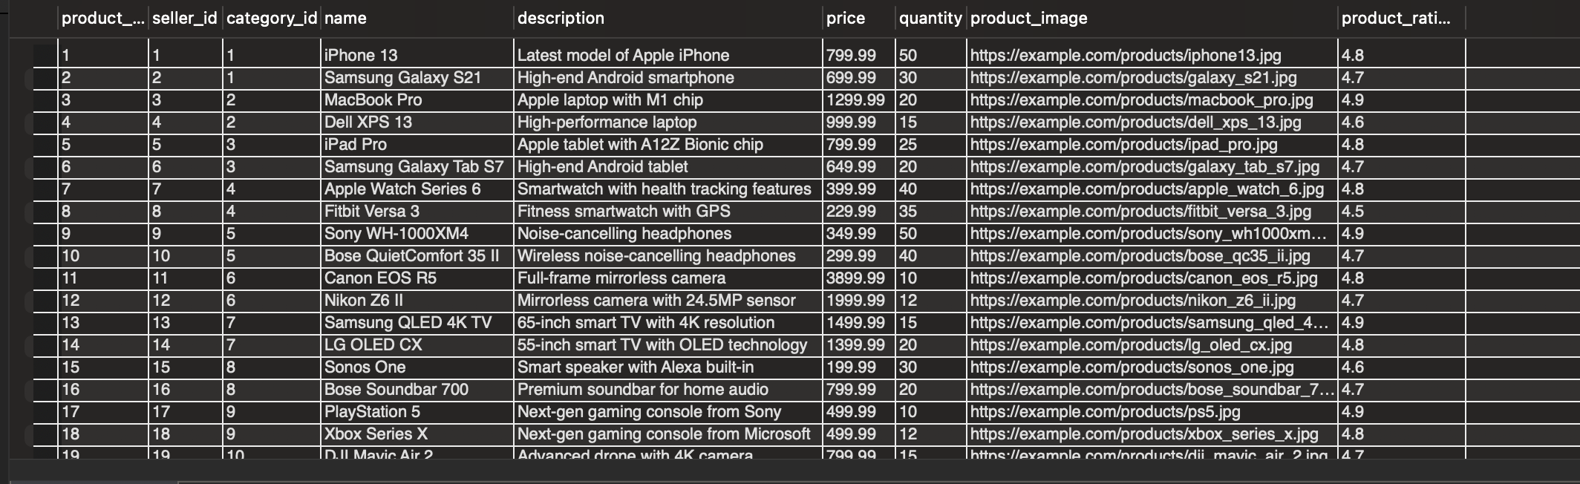

## USER INTERFACE DESIGN

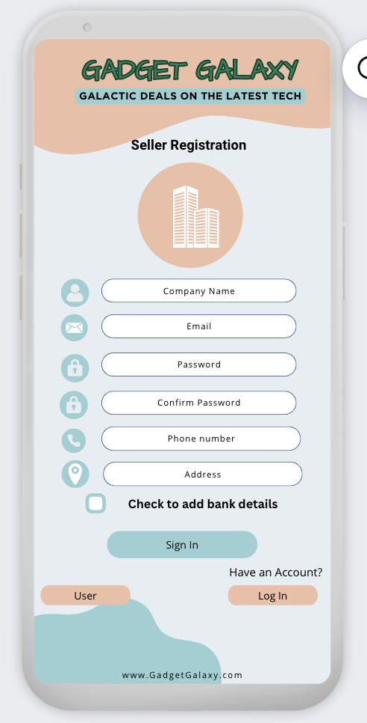 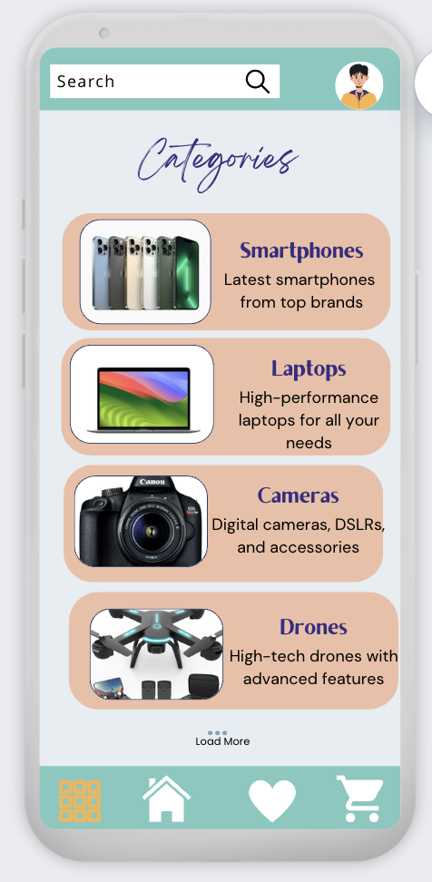 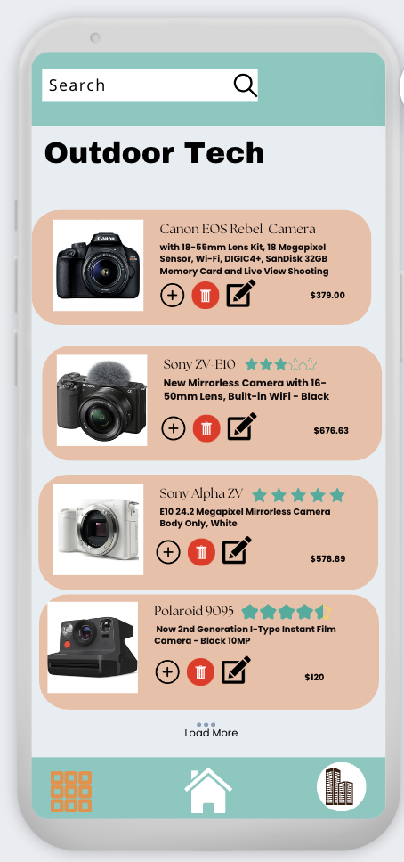

### Seller Registration

**Seller Registration** allows third-party companies to join the **GadgetGalaxy** platform and list their products. The process is designed to be straightforward and secure, ensuring that sellers can quickly start managing their product listings. Sellers provide necessary information such as company name, contact details, password, and business logo. The password is hashed using a secure hashing algorithm before being stored in the database. Seller information, including the hashed password, is securely stored in the Sellers table in the MySQL database. Optionally, sellers may need to verify their email addresses or provide additional documentation for verification.

Seller Registration -screen1





### Categories Display on Category Page

The **Category Page** displays all available product categories, allowing users to browse products within a specific category. Each category has a name and description, providing users with a clear understanding of the product types available.

Categories Display -Screen 2

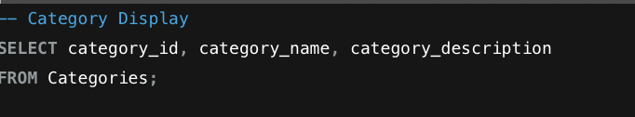

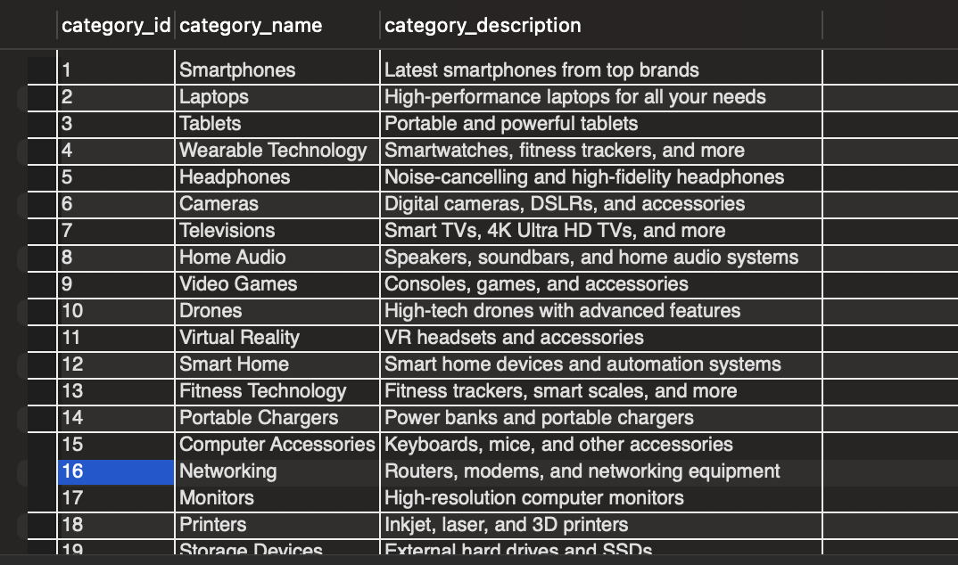

### Product Management on Seller Page

Sellers can manage their products directly from their dedicated **Seller Page**. This includes adding new products, editing existing products, and deleting products that are no longer available.

Seller – Product Management Screen 3

Adding Products: Sellers can add new products by providing details such as name, description, price, quantity, category, and product image.

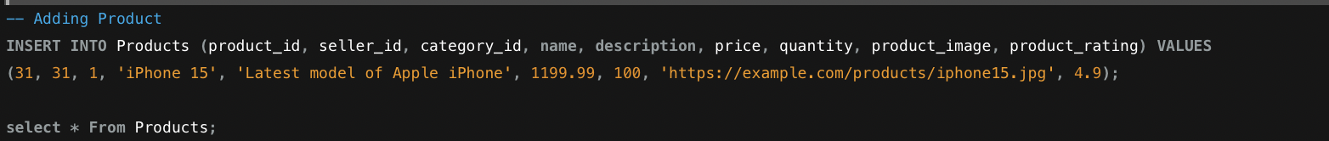



Editing Products: Sellers can update the details of existing products. This includes changing the name, description, price, quantity, category, and product image.



Deleting Products: Sellers can remove products from their listings if they are no longer available for sale.

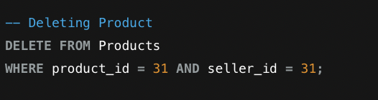



# **PRODUCT LISTINGS**

**In Product Listing** the products are displayed on the home page and platform’s category pages, allowing users to browse and search for items based on various filters and keywords.They can search for an item, add to card or shopping list.They can we the rating, price etc.

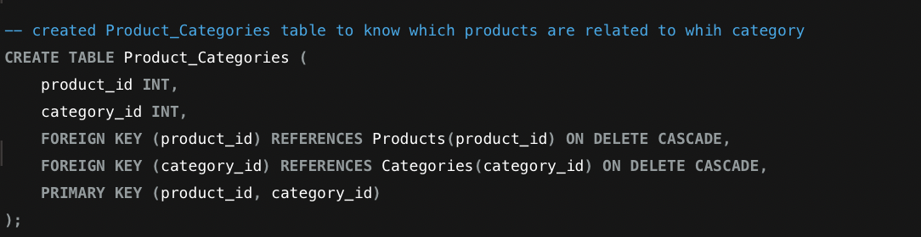

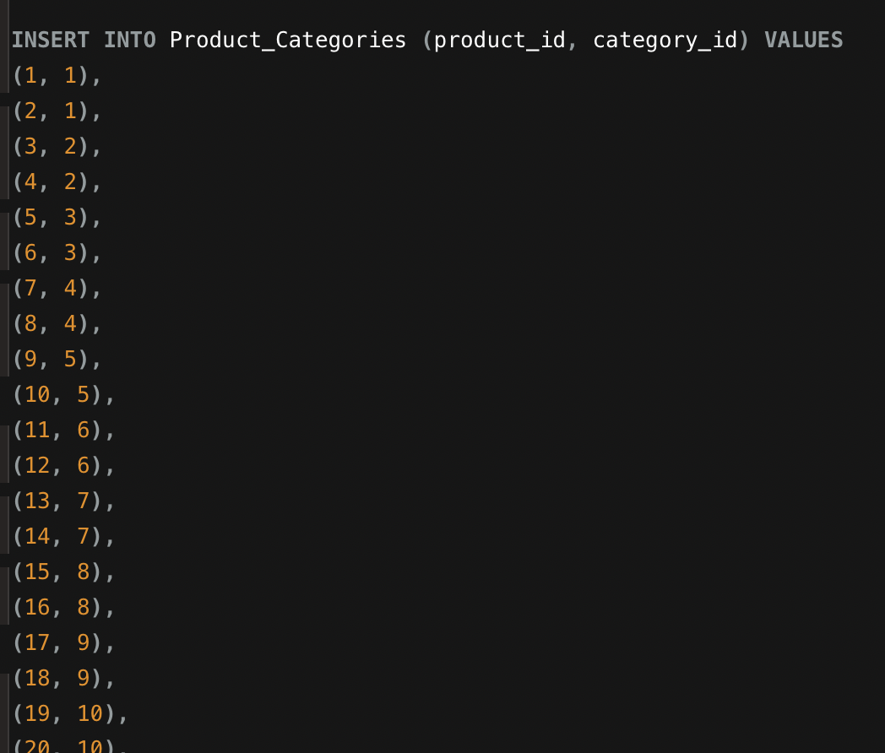 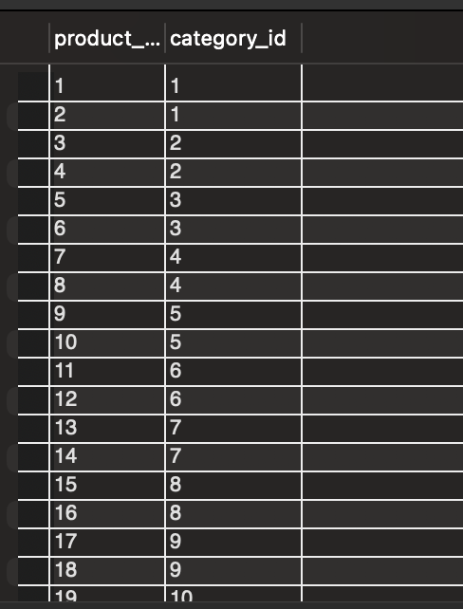

## USER INTERFACE DESIGN

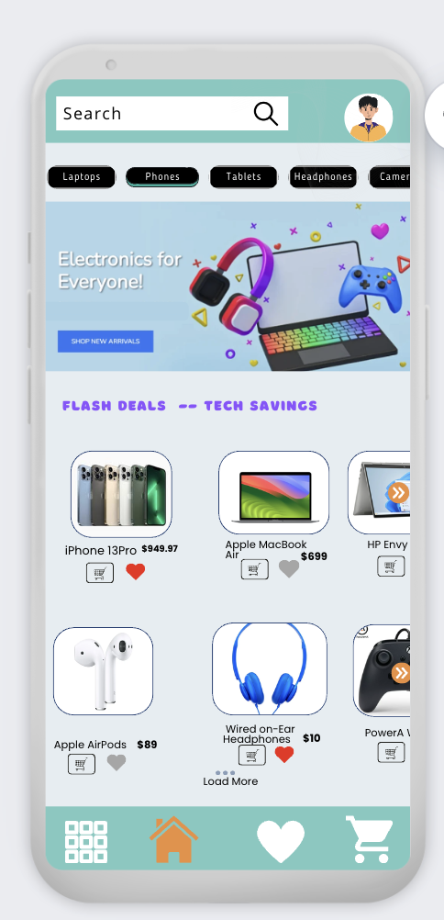 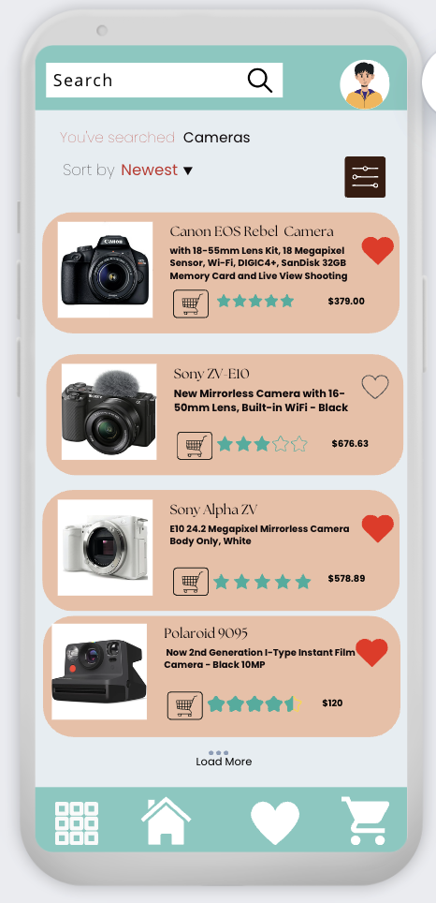

Home Page – screen1

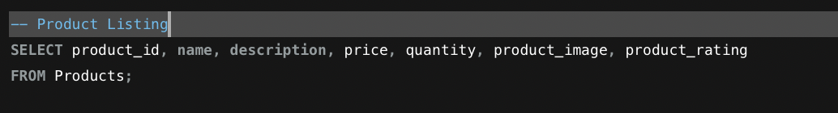

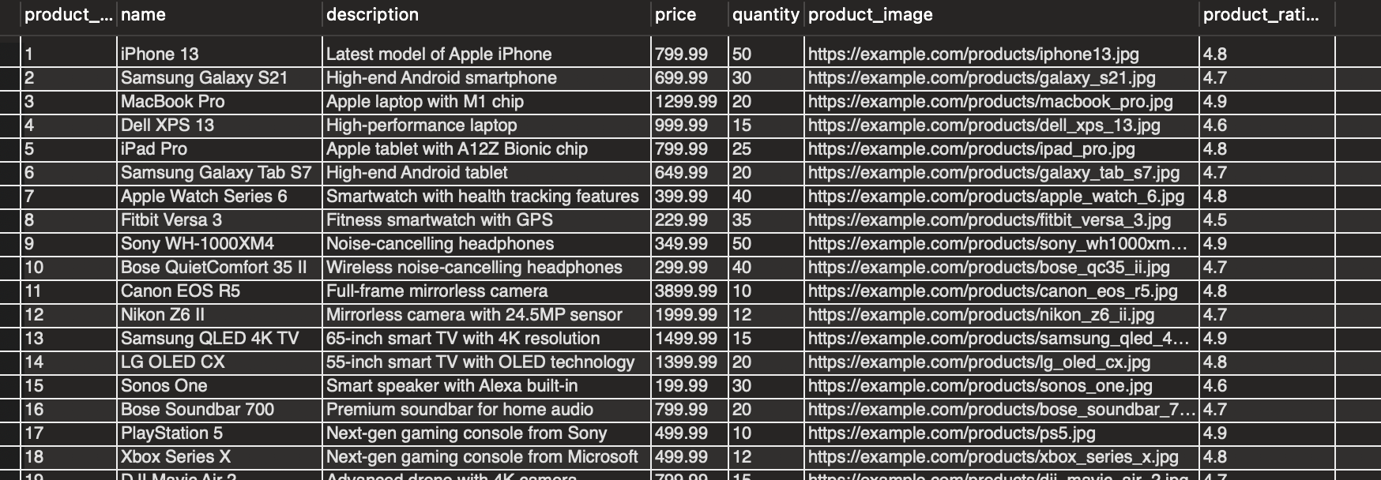

Filter Page – Screen 2

To filter products based on recently added items and include only those related to "camera", We need to use the WHERE clause to search for the keyword "camera" in the product name or description. Additionally, use the ORDER BY clause to sort by the most recently added items.

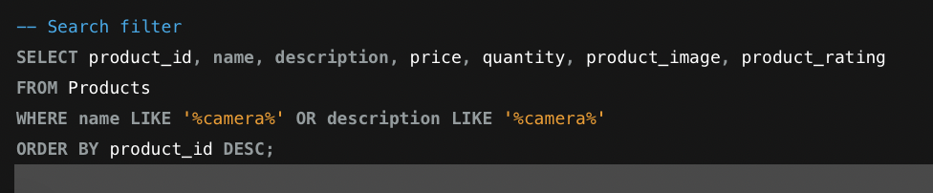

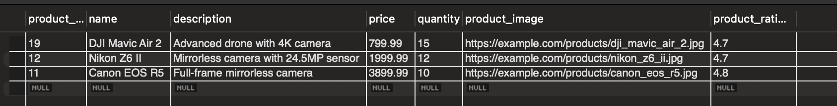

# **SHOPPING CART AND ORDER MANAGEMENT**

The **Shopping Cart** feature in **GadgetGalaxy** allows users to conveniently add products they wish to purchase and manage them before proceeding to checkout. This feature provides a user-friendly interface where customers can review the items they have selected, modify quantities, and remove products if necessary. The users can add products to their shopping cart directly from the product listing or detail pages. Users can view their shopping cart, which displays all selected items along with their quantities, prices, and total cost, and can update the quantity of each item in their cart or remove items they no longer wish to purchase.

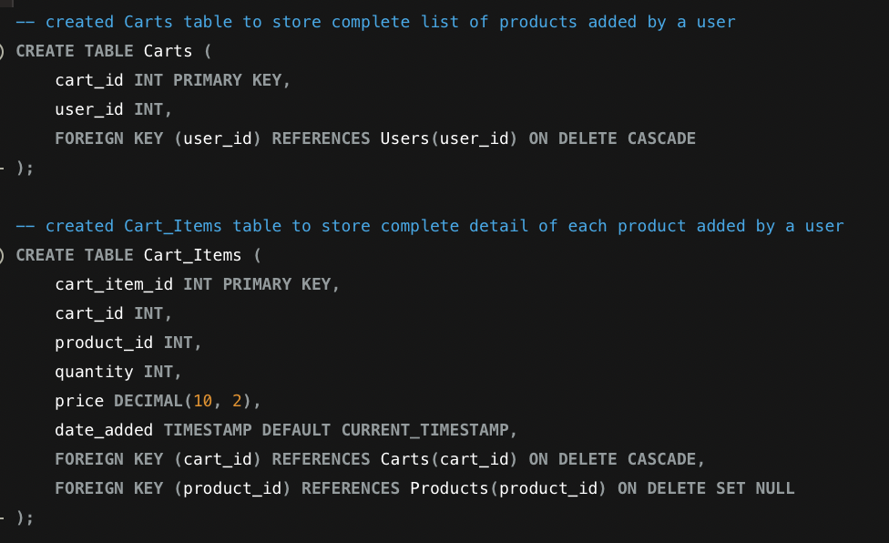

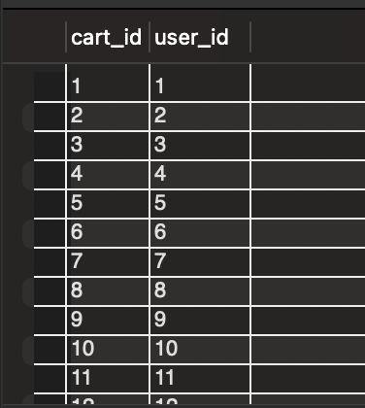 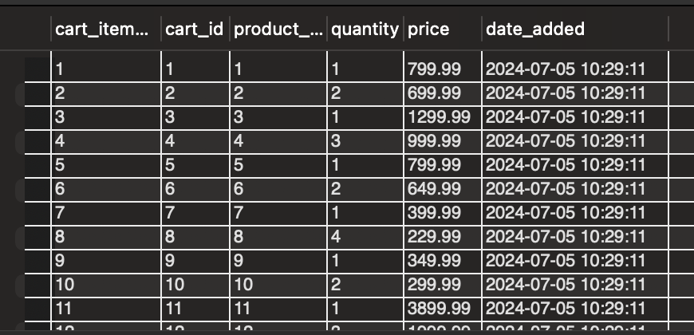

The order management process in GadgetGalaxy is designed to be secure, efficient, and straightforward, guiding users through the steps necessary to complete their purchase. This process includes confirming the items in the cart, providing shipping details, selecting a payment method, and placing the order. Before finalizing the purchase, users are presented with an order summary that includes the list of items, their quantities, individual prices, and the total cost. Once the payment is processed, users receive an order confirmation with details about their purchase and estimated delivery times.

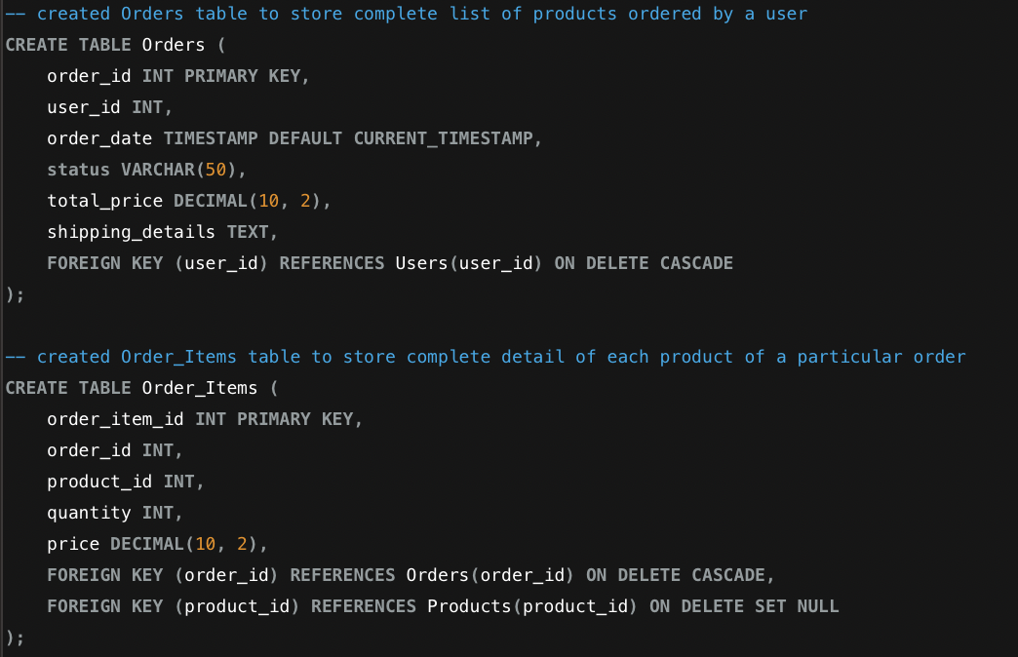

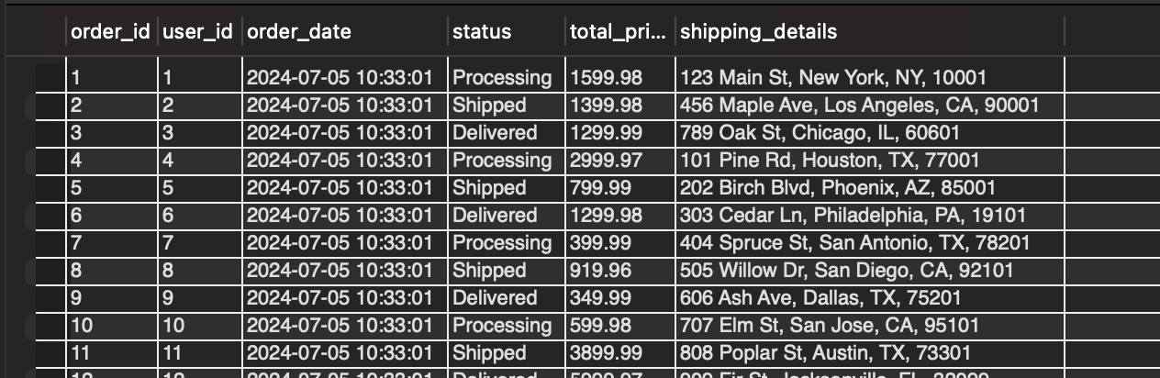

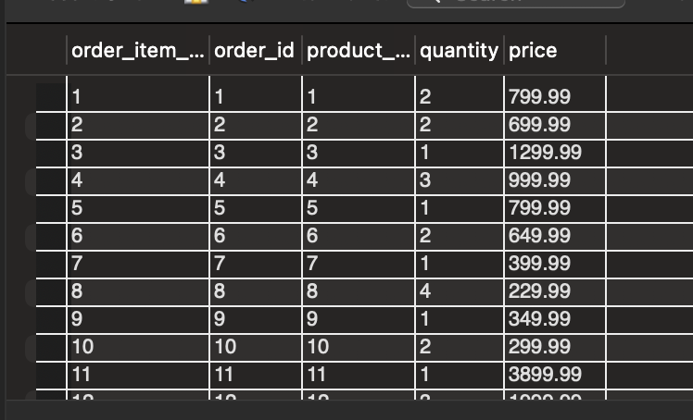

**Payment table**

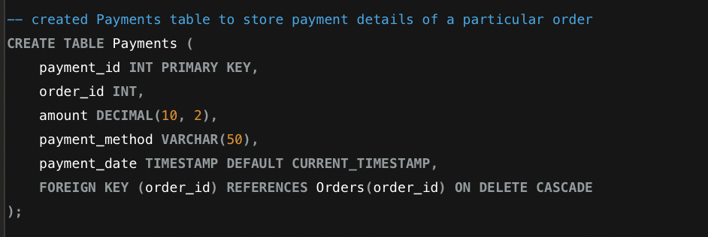

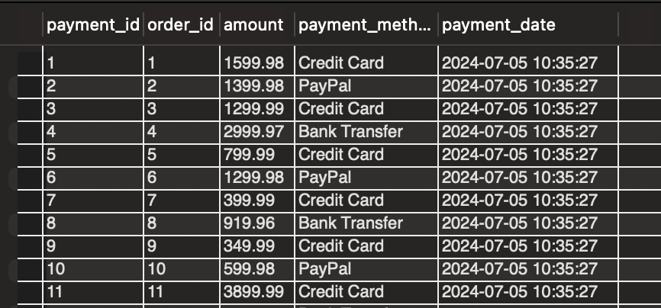

## USER INTERFACE DESIGN

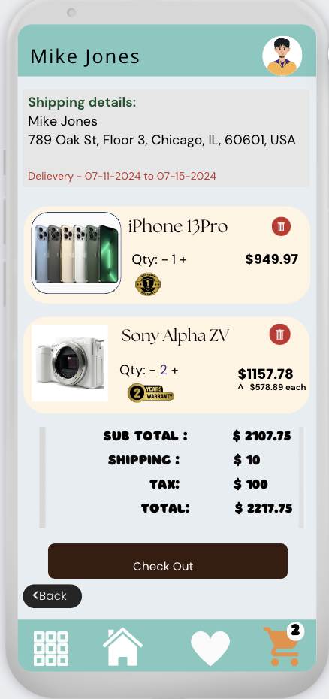 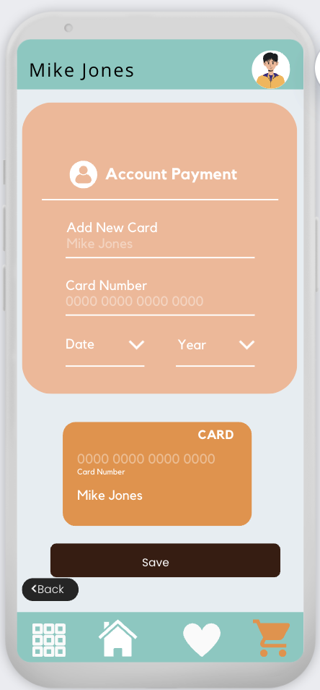 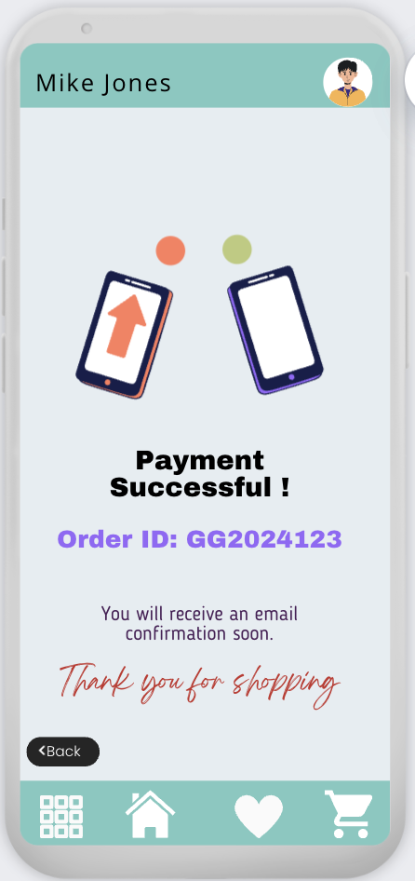

Cart page – Screen1

**View cart items**

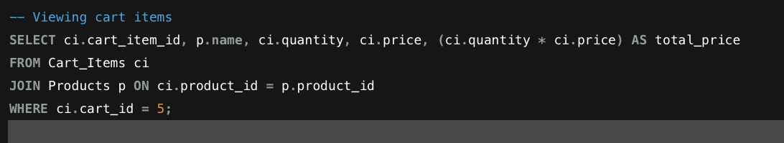

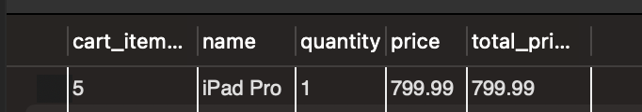

**Delete cart item:**

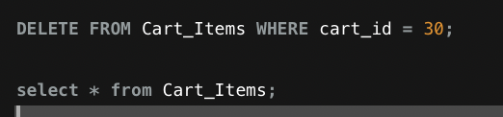



To show the total or subtotal for all items in a specific cart, we can use an SQL query that calculates the sum of the total price for each item in the cart.

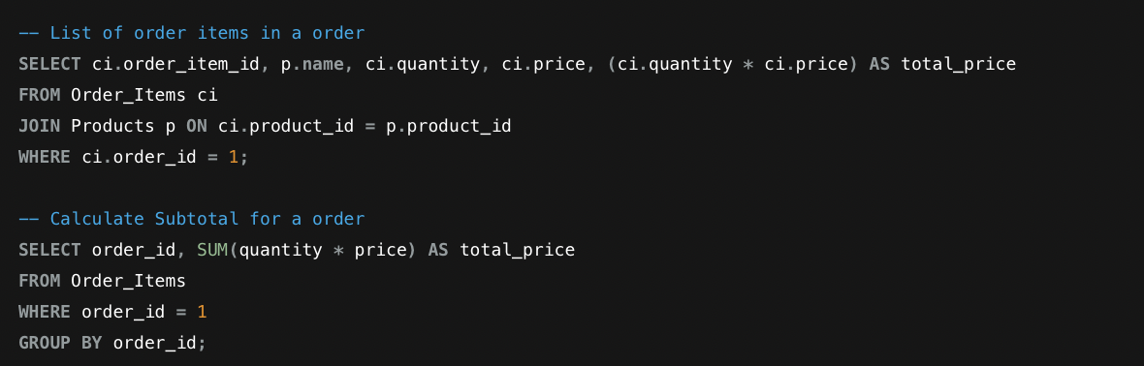

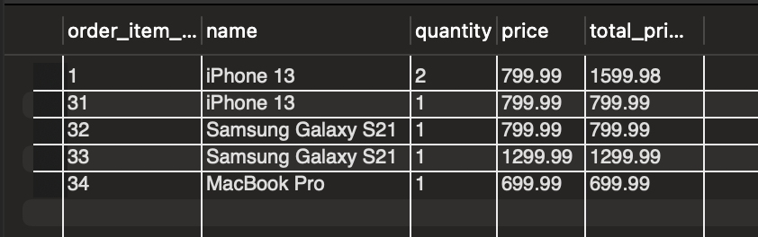 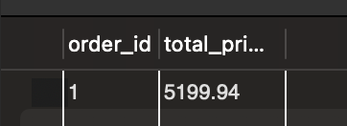

# **USER AND SELLER PROFILES**

User Profiles in GadgetGalaxy serve as personalized spaces where users can manage their account information, view their order history, and update their contact details. The user profile enhances the shopping experience by allowing users to easily access and modify their personal information and keep track of their purchases. Users can view a detailed history of their past orders, including order dates, product details, total amount spent, and order status. They can see the warranty details and can raise a support ticket with the order id.

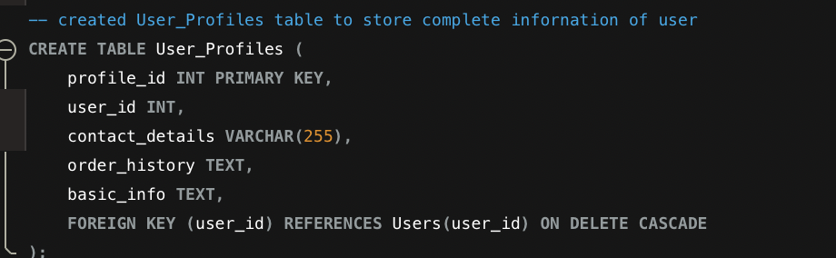

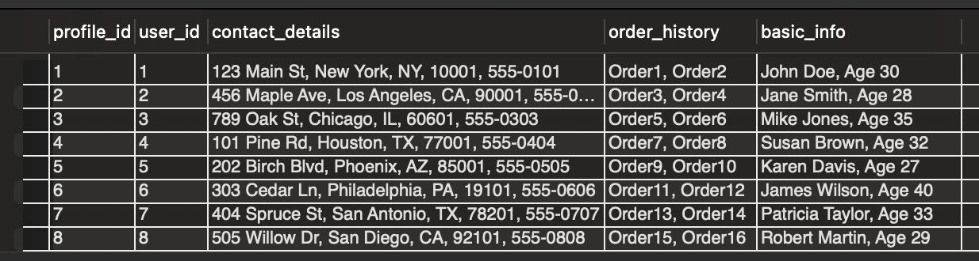

Seller Profiles in GadgetGalaxy provide sellers with a comprehensive interface to manage their products, view sales data, and update their business information. This feature ensures that sellers can efficiently handle their operations and offer the best service to customers. Sellers can update their company name, contact details, business logo, and other relevant information. Sellers can manage their product listings, including adding new products, editing existing ones, and removing products that are no longer available.Sellers can see the reviews given by users in their profile.

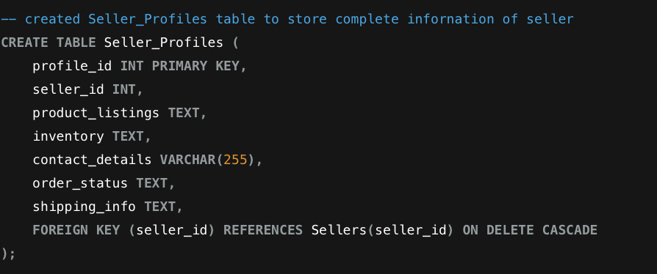

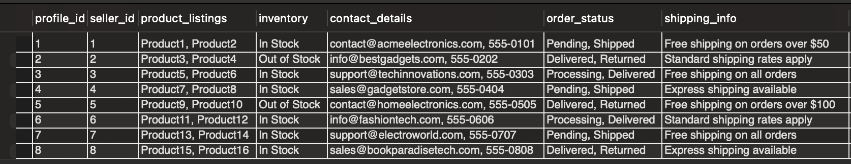

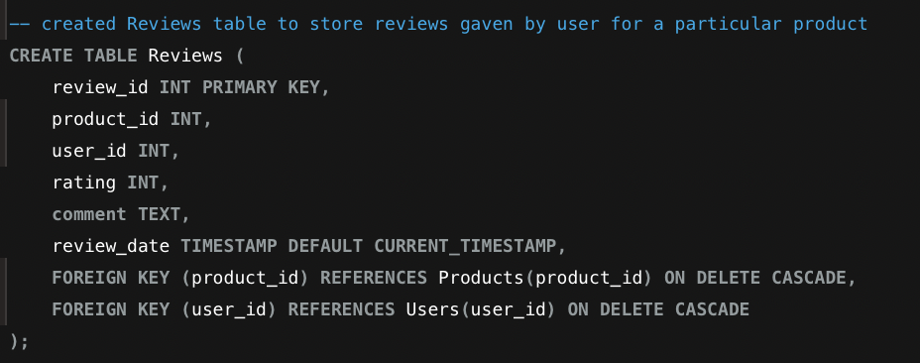

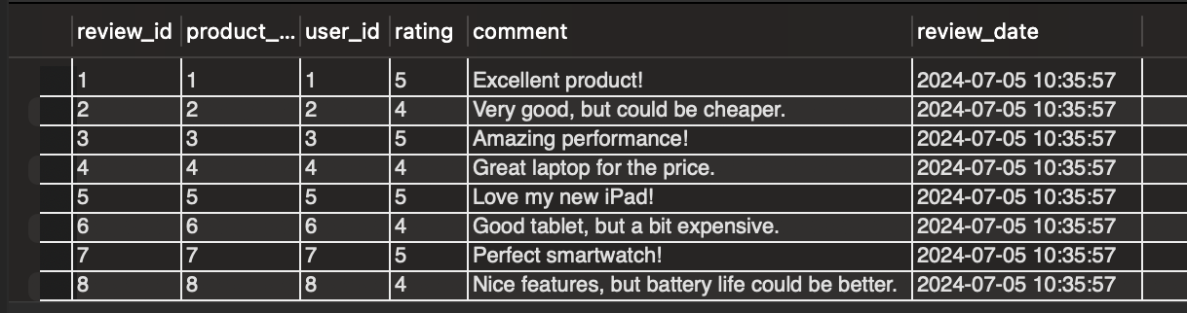

## USER INTERFACE DESIGN

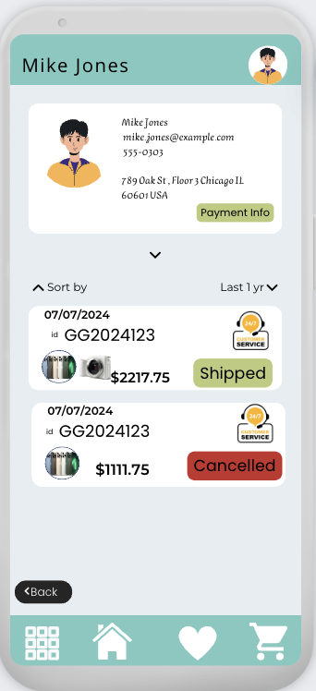 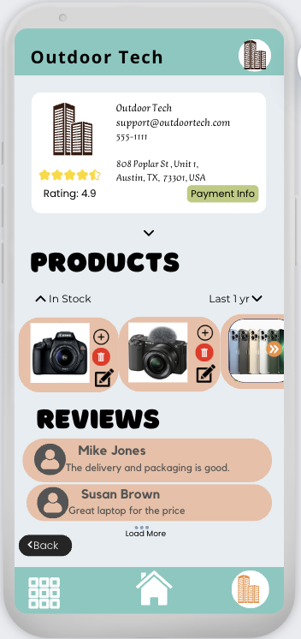

User Profile Screen 1

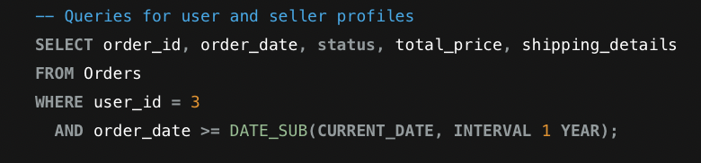

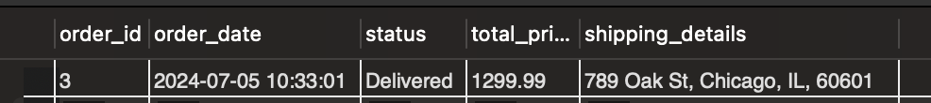

Seller Profile – Screen 2:

**All reviews for a seller**

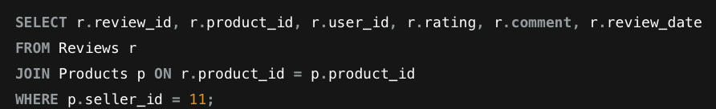

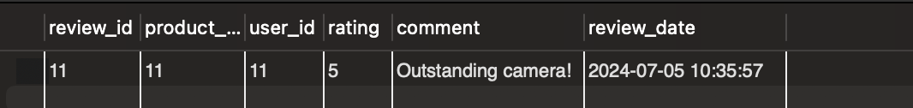

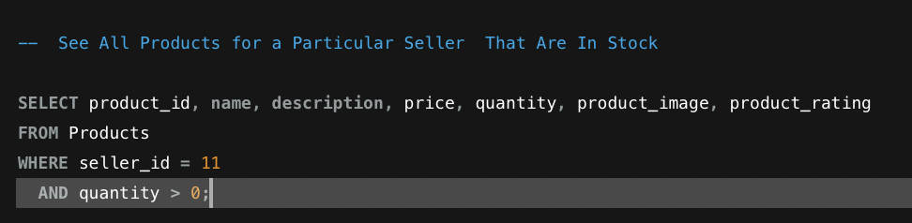



# **RELATED TABLES**

In addition to the core tables for users, sellers, products, orders, and reviews, GadgetGalaxy incorporates several auxiliary tables to enhance the user experience and provide comprehensive support features. These additional tables include Shopping Lists and their Items, Warranties, and Support Tickets

1. The Support_Tickets table enables users to raise issues or queries related to their purchases. Each support ticket includes the user ID, product ID, issue description, status, and timestamps for creation and updates. This structured approach to handling support requests helps GadgetGalaxy provide timely and efficient customer service, ensuring that user concerns are addressed promptly and effectively.

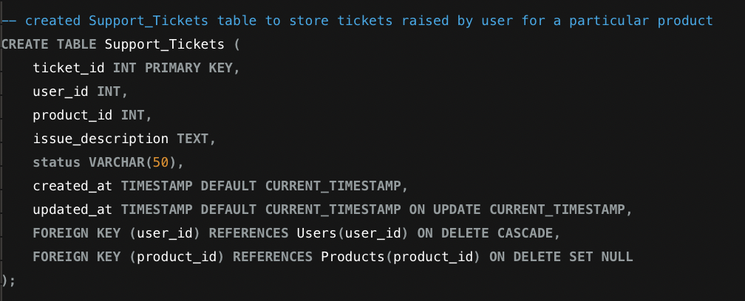

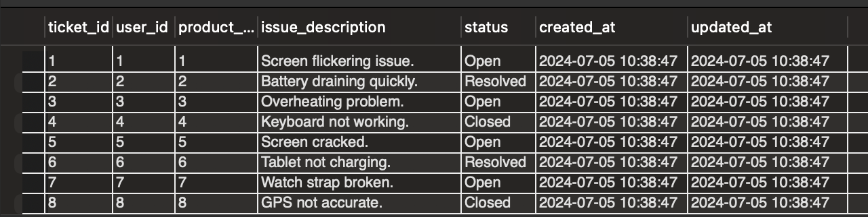

1. The **Warranties** table stores warranty information for products purchased by users. This table includes details such as the warranty period, start and end dates, and associated order and product IDs. By maintaining detailed warranty records, **GadgetGalaxy** ensures users can easily access and verify their warranty information, facilitating smoother post-purchase support and claims.

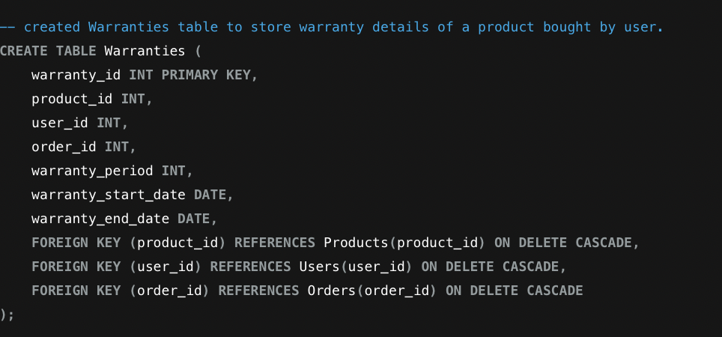

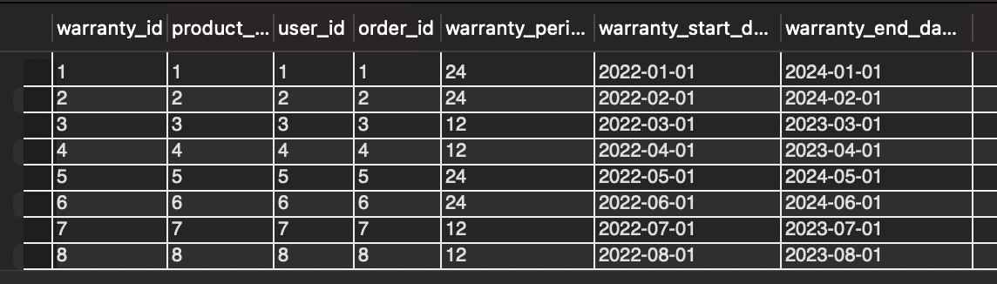

1. The Shopping_List and Shopping_List_Items tables allow users to create personalized lists of products they are interested in but not ready to purchase immediately. This feature enables users to save and organize products for future reference. Each shopping list can contain multiple items, with each item linked to a specific product. This enhances the user experience by providing a convenient way to keep track of desired products without cluttering the shopping cart.

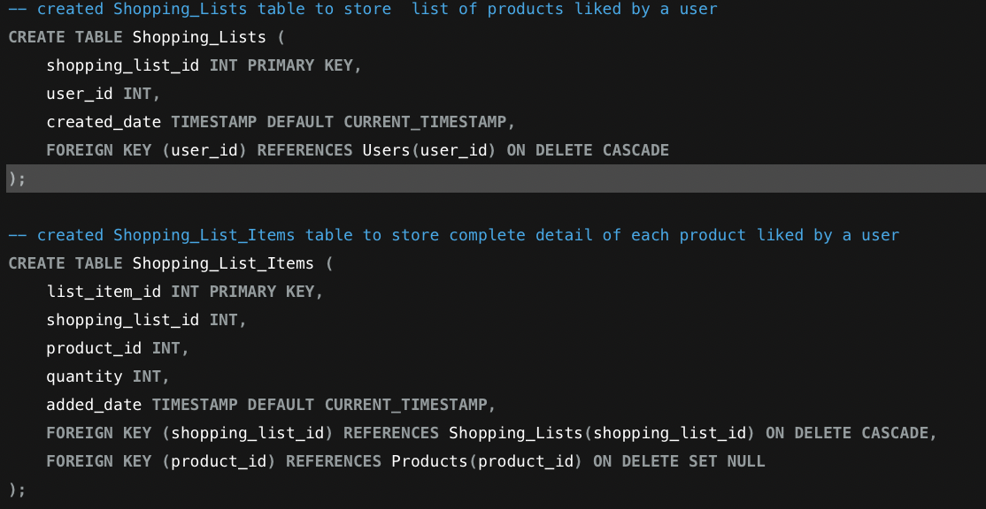

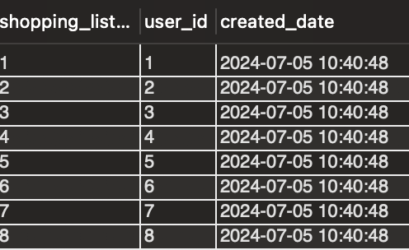

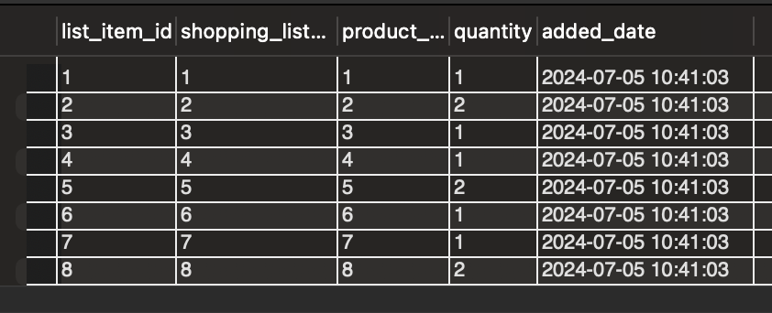

1. Addresses Table

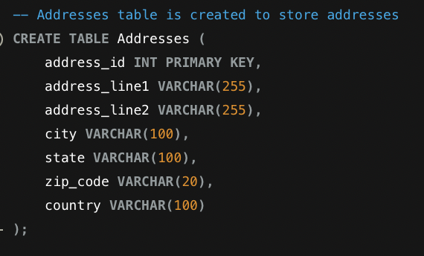

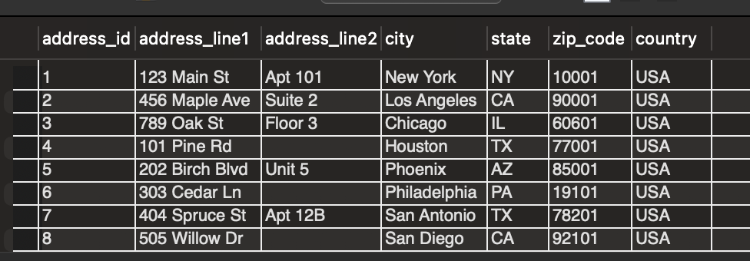

## USER INTERFACE DESIGN

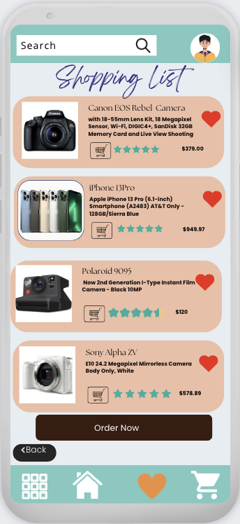

Shopping List – Screen 1

To Retrieve Shopping Lists and Items for a Particular User

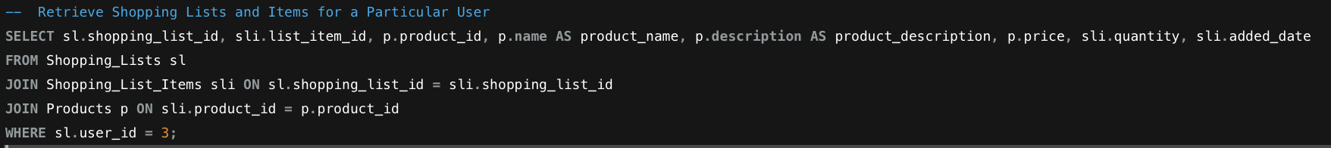



# **QUERIES**

### BUSINESS QUESTIONS:

1. **How many vendors do you have registered?**

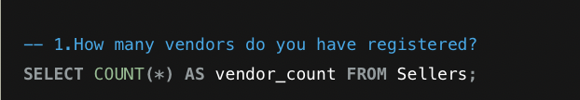

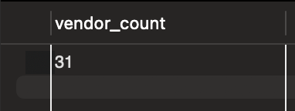

1. **Number of active vs inactive vendors are there with the company (this month)?**

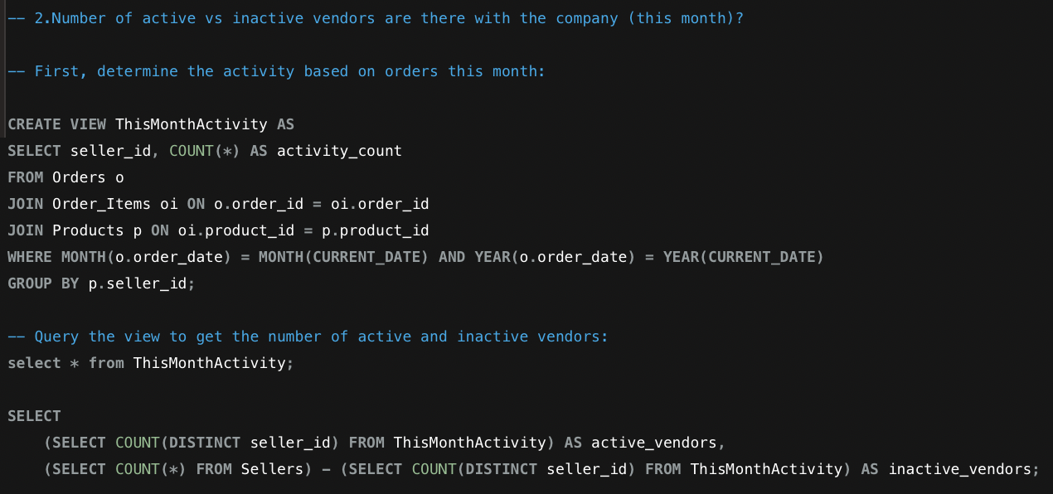

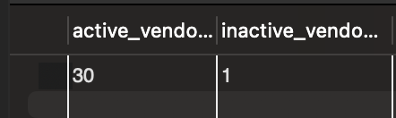

1. **How many customers have registered with your platform from the beginning?**



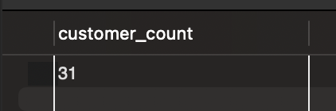

1. **Who is the vendor with the most number listings?**

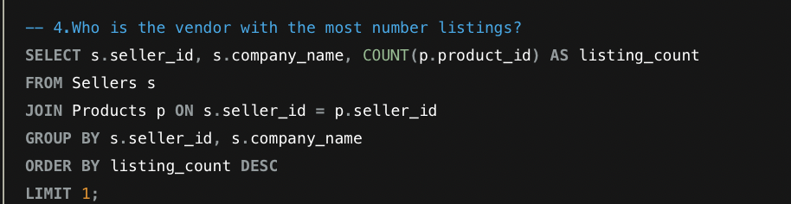

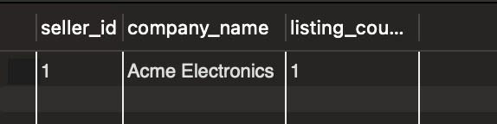

1. **Who is the customer with most number of orders?**

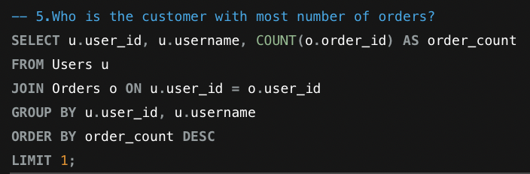

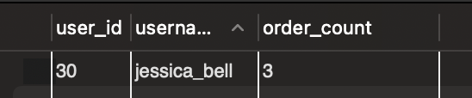

1. **Top 5 vendors by revenue by month- January, Feb, Mar?**

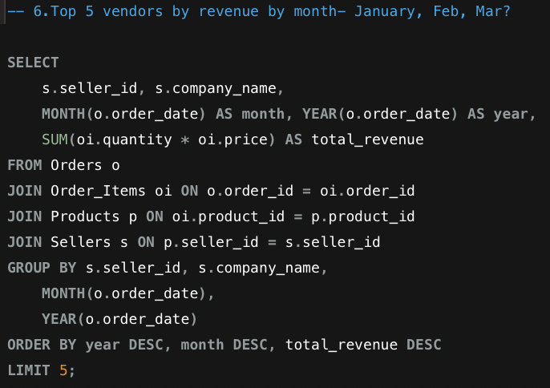

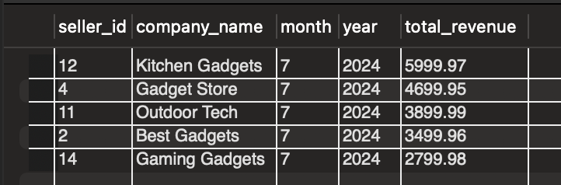

1. **Top 5 customers by revenue this year?**

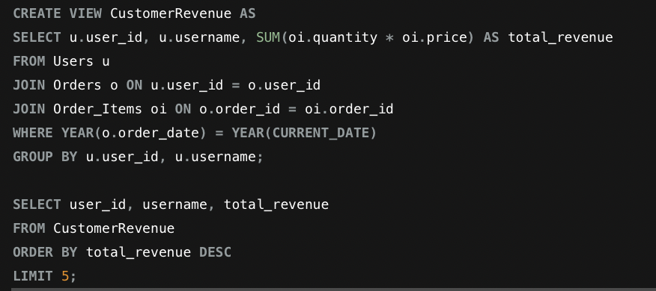

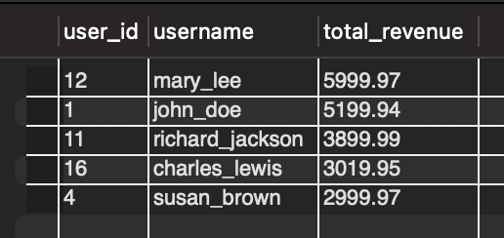

1. **Has our revenue increased this month compared to last year same month?**

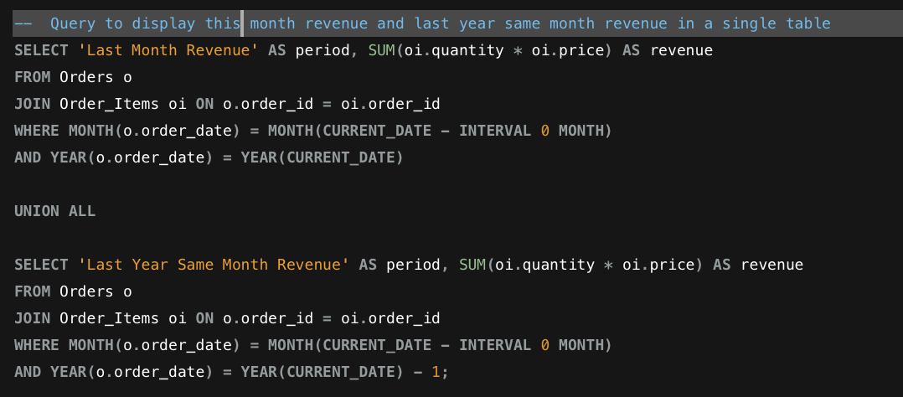

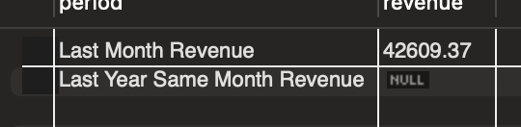

### CUSTOMER QUESTIONS:

1. **What is most expensive order among my orders?**

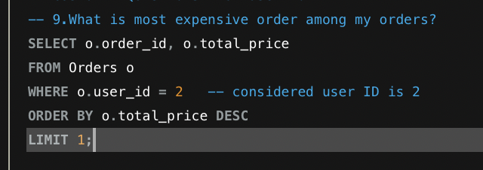

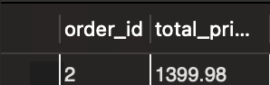

1. **How many orders did I place with your business?**

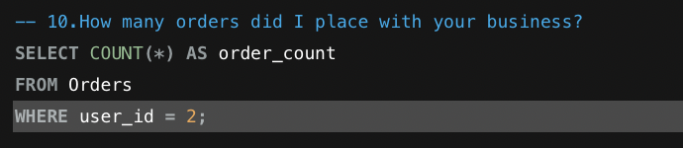

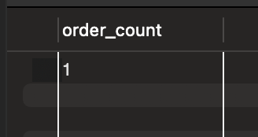

1. **Total historical spend with the business year to date?**

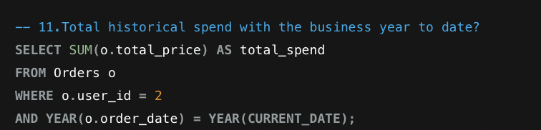

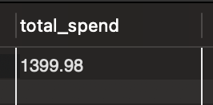

1. **Present the customer with a trend chart of their expenditure, you can use excel for this question, if needed. Use data from your database.**

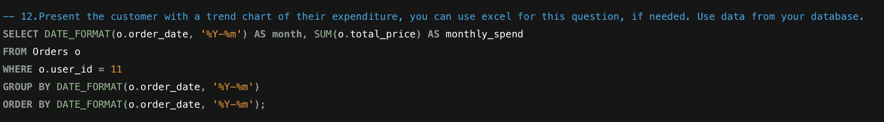

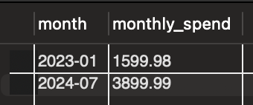 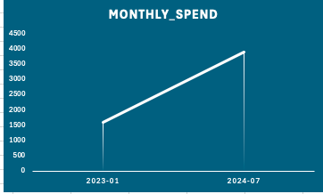

**The above table is the output from the above query for user 11 and the respective line chart.**

### OPERATIONS QUESTIONS:

1. **What is the size of my database? (research database size for MYSQL)**

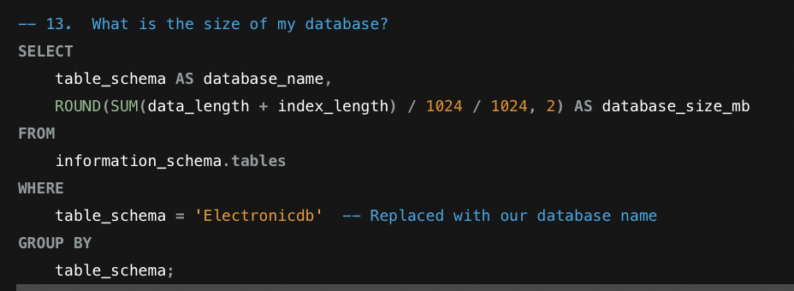

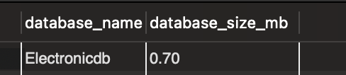

1. **In any of the above queries can you change your database design and reduce the cost of the query?**

There are various ways to reduce the cost of the query by indexing columns[4] that are frequently used in `JOIN`, WHERE, and ORDER BY clauses and can significantly improve query performance.

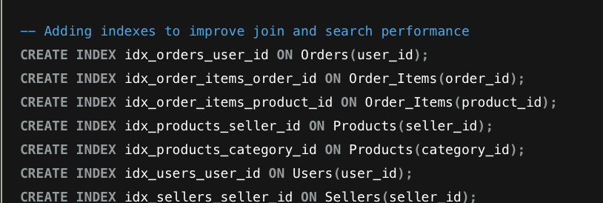

One more instead of views we can directly retrieve the queries if it is least used for question 2

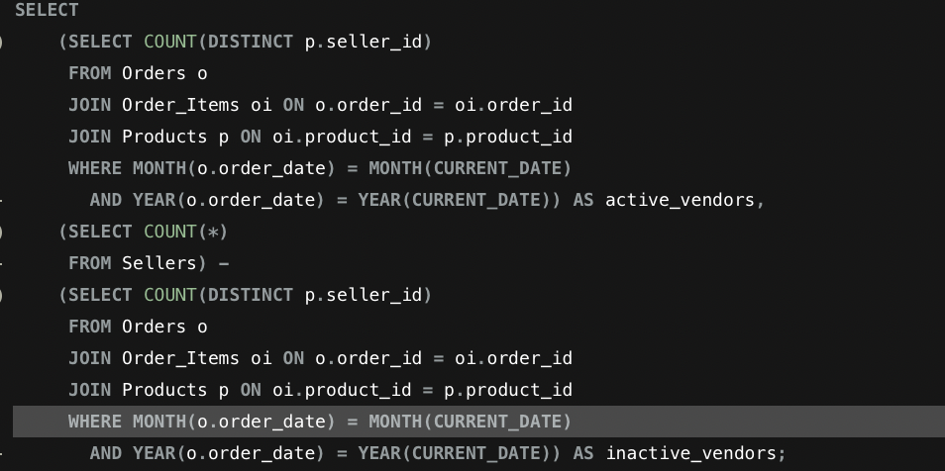

# ADDITIONAL CONCEPTS

## TRANSACTION QUERIES:

### *Placing an Order*

When a user places an order, multiple operations are involved, such as creating an order record, adding items to the order, updating product inventory, and recording the payment. Using transactions ensures that all these operations are executed successfully or none at all.

* **START TRANSACTION**: Begins a new transaction.
* **INSERT INTO Orders**: Creates a new order record.
* **INSERT INTO Order_Items**: Adds items to the order using the order ID.
* **UPDATE Products**: Updates the inventory for the ordered products.
* **INSERT INTO Payments**: Records the payment for the order.
* **COMMIT**: Commits the transaction, making all changes permanent.

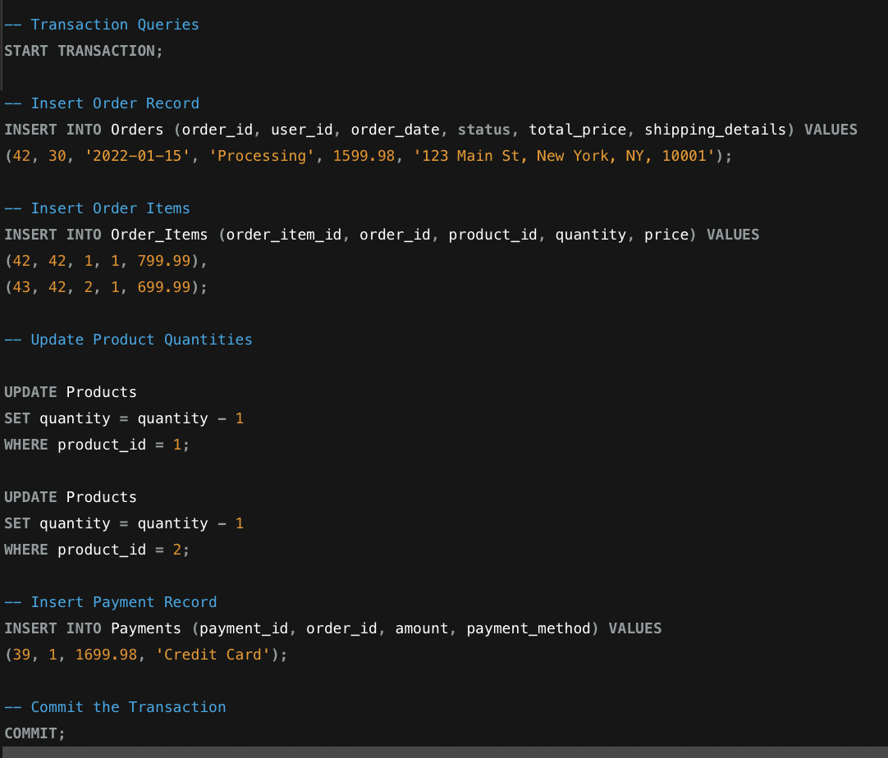

### *Output of tables:*

**Order table:**

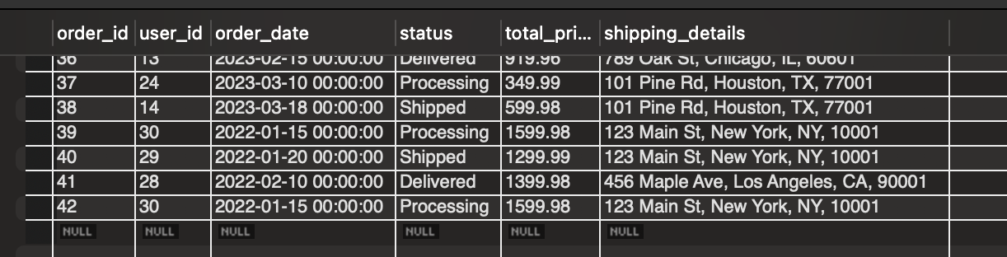

**Order_items Table**

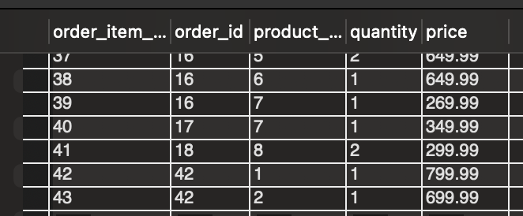

**Product Table**



**Payment tables**

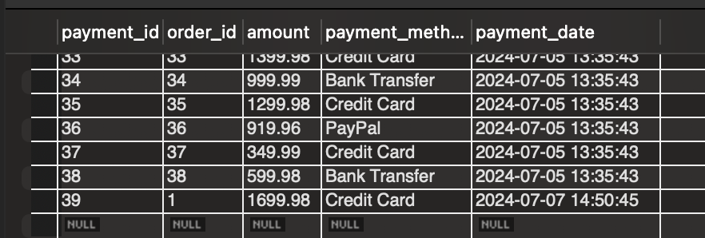

If any step fails, you can issue a ROLLBACK command to undo all changes made during the transaction. This ensures that the database remains consistent and prevents partial updates from being saved.

## MEASURES OF THE IMPACT ON A DATA RETRIEVAL:

We have created few indexes and now lets see how they are helpful for data retrieval. Indexing is a crucial database optimization technique used to improve the speed and efficiency of data retrieval operations. Indexes are special data structures that store a small portion of the table's data in a format that makes search operations much faster. By creating indexes on columns that are frequently used in WHERE, JOIN, and ORDER BY clauses, you can significantly reduce query response times and enhance overall database performance.

We have created idx_orders_user_id. The index on user_id allows the database to quickly find all orders associated with the user with ID 1 without scanning the entire Orders table. This index drastically reduces the number of rows that need to be examined[4].

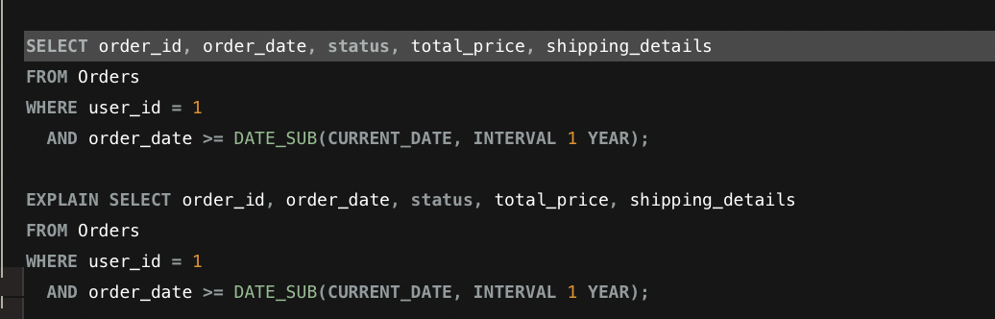

**Output of SELECT Query**



**Output of EXPLAIN Query**

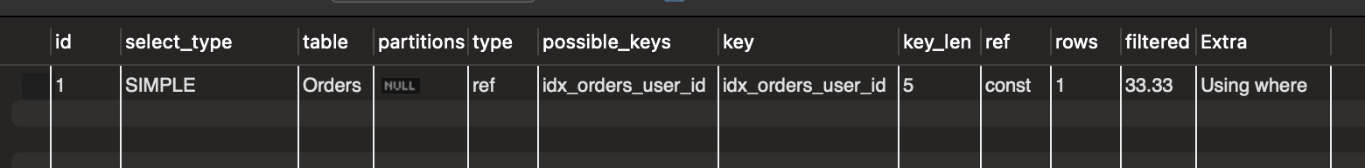

The EXPLAIN statement indicates that the idx_orders_user_id index is used to execute the query. This index helps efficiently filter the rows based on user_id. This optimized approach reduces the number of rows MySQL needs to scan, leading to faster query execution.

# **CONCLUSION**

The **GadgetGalaxy** project provides a comprehensive e-commerce platform used for the efficient buying and selling of electronic gadgets. With a strong emphasis on security and user experience, the project implements user authentication and registration processes with password hashing and optional email verification. Sellers are provided with streamlined product management capabilities, allowing them to easily add, edit, and delete products, thus maintaining accurate and up-to-date inventory information.

Additionally, **GadgetGalaxy** offers an intuitive shopping experience with advanced search and filter capabilities, facilitated by effective indexing for fast data retrieval. The shopping cart and checkout processes are designed to be user-friendly and secure, supporting multiple payment methods and providing clear order summaries. This comprehensive approach ensures that both users and sellers benefit from a seamless and efficient platform, enhancing the overall e-commerce experience. Through careful planning and execution, **GadgetGalaxy** successfully addresses the needs of its users, offering a reliable and dynamic environment for electronic gadget transactions.